**Crestron Certified Integrated Partner Module: SymNet Button Press v2**

**Models:** Symetrix Integrator Series; 722, 760, 761, 780, 788. Jupiter Series; J4, J8, J12. SymNet; 8x8 DSP, Express Cobra DSP, Solus DSP, Edge DSP, Radius DSP.

**Device Type:** Audio Mixer, DSP.

**General Information**

The Crestron Certified Module for Symetrix DSP called SymNet Button Press v2 is very similar to the Button Press v 1. The only factor which has changed is that instead of transmitting a CSG command (Controller Set Global), the module has been changed to transmit a CS (Controller Set), or CS command. The module provides variable fields, present in the module argument definition, in order to place the button trigger variables from the touch-panel, as well as the SymNet Controller number to be activated.

**Category:** Mixer, Audio DSP.

**Version:** 2.0

**Summary:** This button press module is meant to transmit and receive data from any SymNet Controller Number, which is assigned to a parameter which has (2) states.

**General Notes:**

The Button Press v2 will operate on all SymNet DSP units at "Ring #1 Address #1", Edge and Radius. If a Global Controller Set is required to fire across units within a SymNet Ring, or across Rings, Button Press v1 should be used. The [Legacy SymNet Crestron IntegratedPartner Modules](http://www.symetrix.co/product_faq/are-crestron-modules-available-for-symnet-2/) can be found by clicking on the hyperlink.

It is worth reading the SymNet Control Protocol document for the Series to which you wish to communicate with using this module. The SymNet Control Protocol is identical for each series. The factor to consider is whether the SymNet Controller Numbers have already been assigned; as in the case of Jupiter, and Integrator Series, or do you need to assign the SymNet Controller Numbers yourself. Open architecture DSP such as the 8x8 DSP, Express Cobra, Solus, Edge and Radius has open architecture and thus the SymNet Controller Numbers are assigned by the integrator at the time of design.

**Crestron Hardware Required:**

2 or 3 Series. RS-232, or UDP card required.

**Setup of Crestron Hardware:**

*RS-232.* Baud Rate; 38400 to 115200 - Configurable through SymNet Software Application. 8 Bit, Non-Parity, Stop Bit; 1, Flow Control; None.

*Crestron Cable Type.* CNSP-121

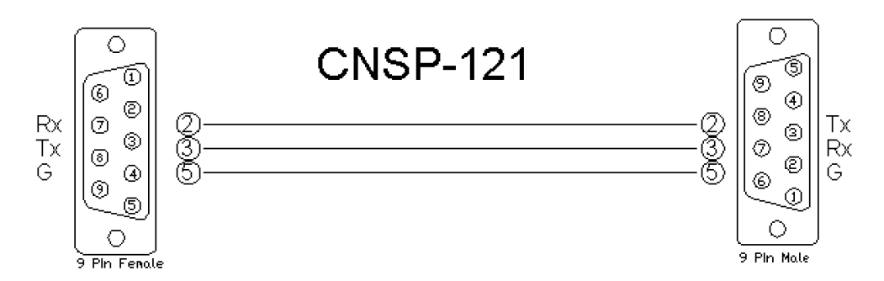

*UDP/IP.* Port: 48630.

**Application Notes:**

This Button Press v2 module is compatible with all SymNet DSP units; all Software and unit Firmware versions. Those DSP which are programmed with SymNet Designer; 8x8 DSP, Express Cobra, Solus units, used the Legacy architecture of Numbered Rings and Unit Address Numbers within those rings.

Those DSP which are programmed with SymNet Composer; Edge and Radius, use Dante to transmit digital audio and control between units. These units will only respond to the CS Controller Set command used in the Version 2 modules. They do not respond to the CSG Controller Set Global command used in Version 1. This is due to the fact that the concept of the SymLink ring has gone away.

The Integrator will designate the parameter to be controlled in the SymNet DSP by using the "right-click" menu in SymNet Composer and assigning an RS-232/485 SymNet Controller Number to the parameter. There are up to 9,999 SymNet Controller Numbers that can be assigned within the DSP system. The scale of value for each SymNet Controller Number is 0 to 65,535. If the parameter has 2-states, a Controller value above ½ of the value of 65,535 the parameter will go active. If the string CS 32,768 is sent the parameter will go active. If the string 32,767 is sent, the SymNet parameter will go in-active, or low.

**Module Graphic:**

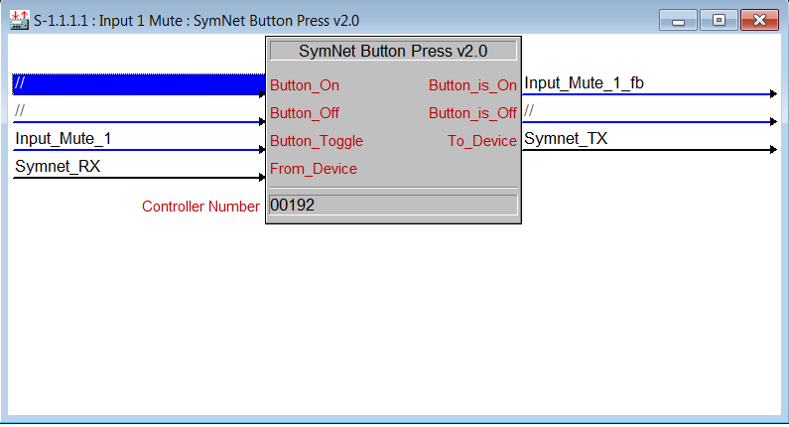

**Control:**

*Button_On/Off/Toggle.* Signal Type: Digital. Pulse to turn the function on, or off.*From_Device.* Signal Type: Serial. Serial signal to be routed from a 2-way serialCOM port, or a UDP/IP symbol.

**Parameters:**

*Controller Number.* Signal Type: Variable to be entered by the integrator. Enter the SymNet Controller Number for the function you wish to control. For SymNet Legacy units this parameter will require the leading zeroes.

**Feedback:**

*Buttton_is_on/Off.* Signal Type: Digital. High to indicate the current state of the function. *To_Device.* Signal Type: Serial. Serial signal to be routed to a 2-way serial COM port or UDP/IP symbol.

**Testing:**

*SymNet OS.* SymNet Designer v10.06, SymNet Composer v1.1, Jupiter Software v2.0.1.12, Integrator Series 761 Software v2.01. *SIMPL OS.* 4.01 *Crestron DB.* 35.00.004.00 *Sample Program.* Symetrix 761 Demo for MC3 and TPS6 *Revision History.* 2.0